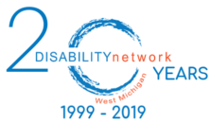

IS YOUR BUSINESS ACCESSIBLE?

LET US HELP!

*FREE ACCESSIBILITY REVIEW*

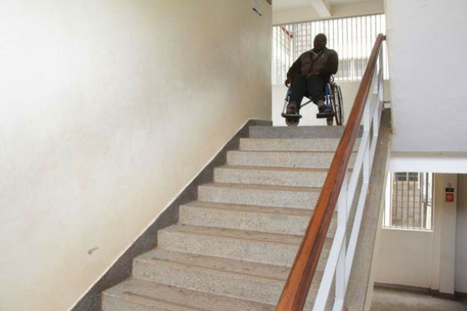

*Are you interested in advancing your inclusion and diversity efforts? We are*

*here to help! Let Disability Network West Michigan conduct an on-site*

*accessibility review of your business/ organization to determine ways and*

*opportunities to make your business more accessible. This is a* ***FREE*** *opportunity*

*to Muskegon County businesses funded by a grant from the Community*

*Foundation for Muskegon County.*

Please choose one of the following:

**YES**, my business is interested in advancing greater inclusion and

diversity through the opportunity of a **FREE** accessibility review.

**NO**, my business is not interested in inclusion and diversity at this

time.

If you answered **YES**, please fill out the information below and we will follow up

with a brief phone interview to make sure you and your business or

organization are a good fit!

Business Name: Click here to enter text.



Business Owner Name: Click here to enter text.

Project Lead Contact: Click here to enter text.

Address: Click here to enter text.

Phone Number: Click here to enter text.

Email: Click here to enter text.

Please return completed form to Brad Hastings at [bradh@disabilitynetworkwm.org](mailto:bradh@disabilitynetworkwm.org)

Or call 231-332-4037 for more information