Cooking at the CIL
Wednesday, December 16
THE FIRST 5 TO REGISTER WILL BE PROVIDED ALL THE INGREDIENTS TO MAKE THESE DELICIOUS COOKIES!

NO BAKE COOKIES
1 ¾ White sugar 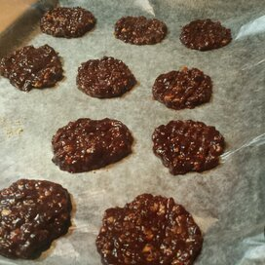
½ cup milk
½ cup butter
4 t ablespoons unsweetened cocoa powder
½ cup crunchy peanut butter
3 cups quick-cooking oats
1 teaspoon vanilla extract
Directions
Step 1
In a medium saucepan, combine sugar, milk, butter, and cocoa. Bring to a boil, and cook for 1 1/2 minutes. Remove from heat, and stir in peanut butter, oats, and vanilla. Drop by teaspoonfuls onto wax paper. Let cool until hardened.

ORANGE NUT BALLS

Ingredients
1 12 oz box vanilla wafer cookies, crushed
3/4 cup powdered sugar
½ cup melted butter
1/2 cup walnut pieces or any other chopped nut
1/2 cup orange juice concentrate

Instructions
Combine ingredients, mixing well until evenly coated.
Roll into 1" balls with your hands and place on a wax paper lined baking sheet. Refrigerate for at least an hour.
Store in an airtight container and keep refrigerated
Freezes well!

